Log in instructions for MRI Web

You’ve received a MRI Userid and temporary password

Log into HG360 and click on the MRI Version X icon/link

Enter ClientID here (N056999) then click arrow to continue

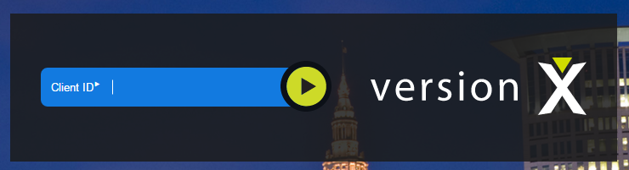

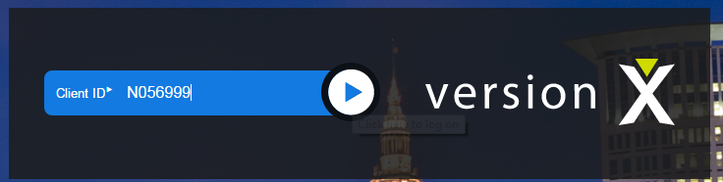

Enter MRI UserName sent to you in email. Enter temporary password

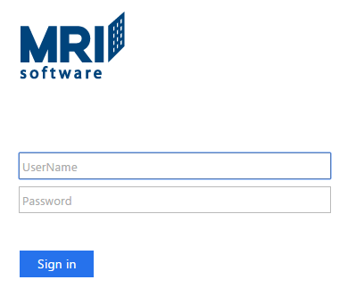

You must change from temp password to a new one at your first log in.

* Be sure to use 8 characters total in your new password
* Use at least one capital letter within the 8 characters
* Use at least one number within the 8 characters

Write down and save your password (we will not have access to your password)

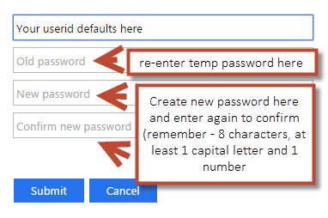

Click the Submit button.

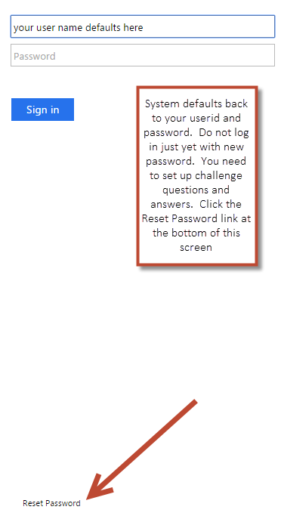

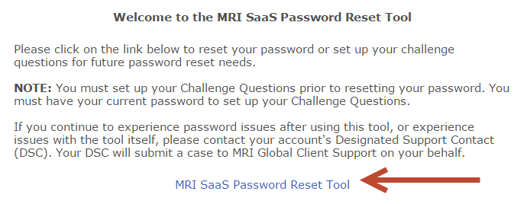

Click on the blue link MRI SaaS Password Reset Tool

Click the Create button in the Welcome to the MRI SaaS Password Reset Tool.

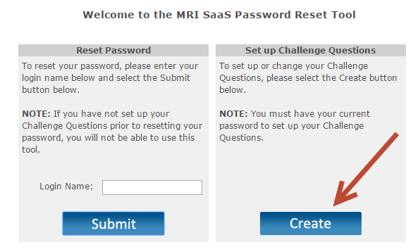

Your user name defaults in Login Name.

Enter your current password.

Click Sign In.

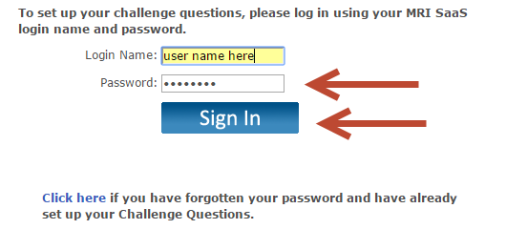

This takes you to the Challenge Question / Answer set up process

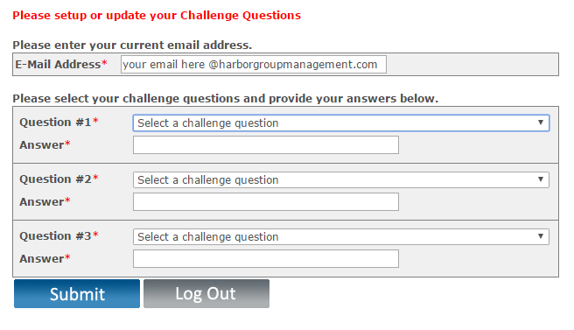

Create your questions / answers. You can use drop down or create your own. Enter answer.

***Hint:*** You may want to use the same answer for all questions (easier to remember) – Be sure to write this information down in a safe place for reference later when using the reset tool.

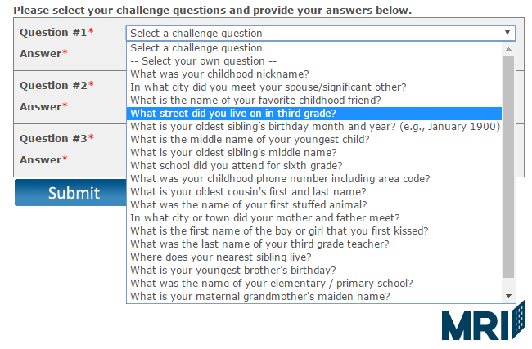

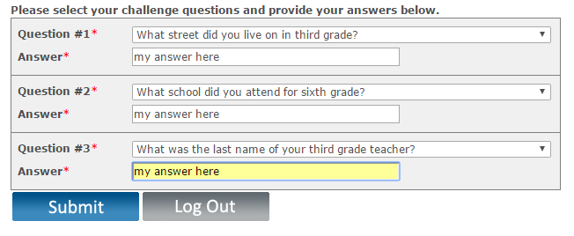

Once all 3 questions and answers are created click the Submit button to record and close screen. The below screen defaults after you submit your challenge question/answer set up.

Simply click the Close option in top right corner.

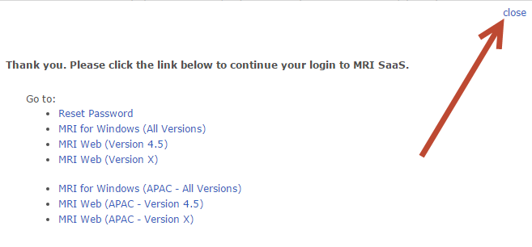

Click the X to close again.

